**Lab 3: Oscilloscope**

**Lab Report by: Talal Jawaid**

**Lab Session: Wednesday**

**Due Date of the Lab: 3/7/18**

**Date(s) of the lab: 2/14/18-2/21/18**

**Lab partner(s): Sergio Zavala and Amrit Singh**

1. **Introduction**

In this lab we learned how to use an oscilloscope to measure the different aspects of a voltage wave, such as the period, frequency, and amplitude. We used an oscilloscope to verify that voltage and frequency coming out a function generator matched what the function generator said it was outputting.

1. **Purpose**

The purpose of this lab is to familiarize us with the oscilloscope and its’ various functions. An oscilloscope is a very powerful tool which allows us to measure the voltage wave coming out of a circuit at any point or to verify that a power supply is working correctly. The difference between an oscilloscope and a voltmeter is that a voltmeter won’t show you the voltage wave, and won’t give you many other details about that voltage wave.

1. **Discussion and Results**

**Part1:**

**Procedure:**

For this part we had to use the X1,X10, and X100 probes but the X100 probe was not available for us to use. We had to use the function generator to create a 1KHz sinusoid with 1Vpp and 0 V DC offset. At this moment the probe was connected to the function generator through channel 1 and channel 2 was used to calibrate the voltage through the calibrator loop. As soon as it turned on, the wave showed up on the scope. We were asked to check the differences between readings in the X10 and X1 probes.

**Data:**

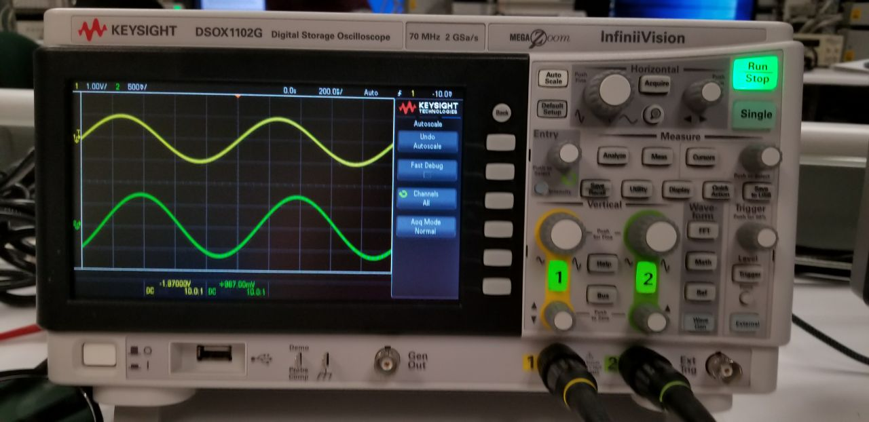

**Analysis:**

Observation – “Which do you think is the correct reading?”

We believe both are correct but that the X10 is a better reading because it amplifies the voltage to be better able to read. It is like a magnifying glass in the sense that it is a closer look at the voltage wave coming out of the function generator.

Observation – What happened to the trace, provide explanations for your observations?

The DC wave moves up by 1 volt at every point due to the 1 volt DC offset. This shows the true voltage of the circuit. If you set the probe to AC coupling, it shows it stuck at the same spot, no matter what the DC offset is. This is due to the fact that when the oscilloscope is in AC coupling mode, it ignores the DC offset.

**Part 2:**

**Procedure:**

For this part of the lab, we used the same 1Vpp sine wave that was used in Part 1. We changed the settings of scope so that we could use the trace, time delay, and slope/coupling functions. When the triggering mode was changed from AUTO to NORM, it changed the triggering mode.

**Part 3:**

**Procedure:**

For Part 3, we had to connect the function generator to the DMM and the scope and measure the readings out of those. After we did that, we added a 51 ohm resistor and then made the same readings. This was done due to the fact that internal resistance of the scope is about 51 ohms as well. We then had to connect our RC circuit and make the same measurements. We then checked whether our measured and calculated values agreed.

**Data:**

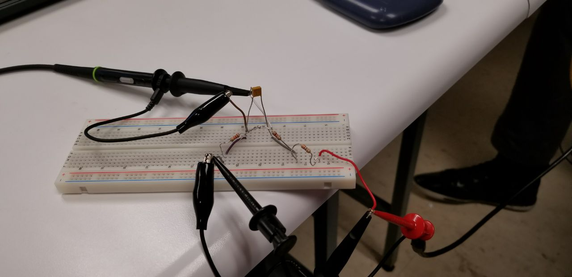

|  |  |  |
| --- | --- | --- |
| **Vp-p(SCOPE)** | **Vrms(SCOPE)** | **AC(RMS)(DMM)** |
| **1.04** | **357mv** | **354mv** |

**51.73Ω (measured)**

|  |  |  |
| --- | --- | --- |
| **Vp-p 51Ω** | **Vrms 51Ω** | **AC(RMS) 51Ω** |
| 2.53 | 670mV | 353mV |

|  |  |  |  |  |
| --- | --- | --- | --- | --- |
|  | **Frequency(in)** | **Frequency(out)** | **Period** | **Time delay** |
| **Figure 1** | 1.000kHz | 999.99MHz | 996ns | 131ns |

**Analysis:**

As you can see, our AC RMS values were very similar to our Vrms values. This is likely due to the fact that there was no DC offset. Since the equation for phase shift is

Phase shift = 360* timedelay/period.

Using our values for 131ns as our time delay, and 996 ns as our period, we determined our phase shift to be 47 degrees, which is very close to the goal of 45 degrees phase shift.

1. **Conclusion:**

In conclusion, we used the oscilloscope and its many functions to measure the voltages coming out of both a function generator and our RC circuit. The oscilloscope is a very powerful tool which allows use to view the waveform of different voltage supplies and several different measurements which include frequency, amplitude, and Vrms, among others. Since our value of phase shift was only two degrees off from the goal of 45 degrees, we believe this lab to be a success. Any errors can be attributed to mistakes in our calculation for R, whether these be mathematical logic errors or simply due to rounding. Since the oscilloscope is a very accurate and precise tool, we don’t believe that to be the source of our errors.